https://www.yeetpc.com/blog/nginx-reverse-proxy/

Reverse proxy server

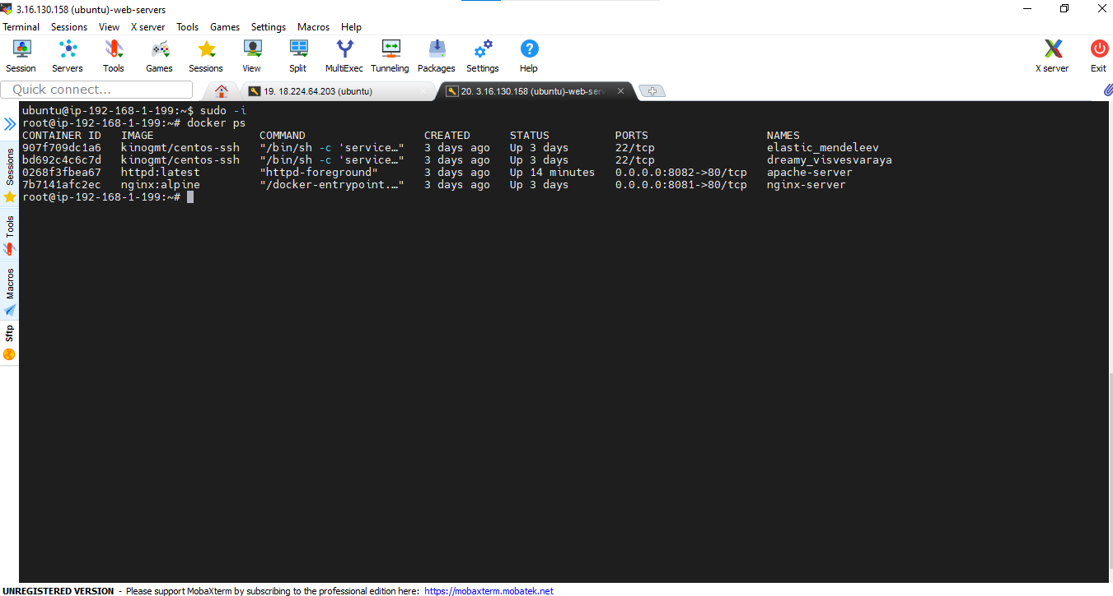

Docker

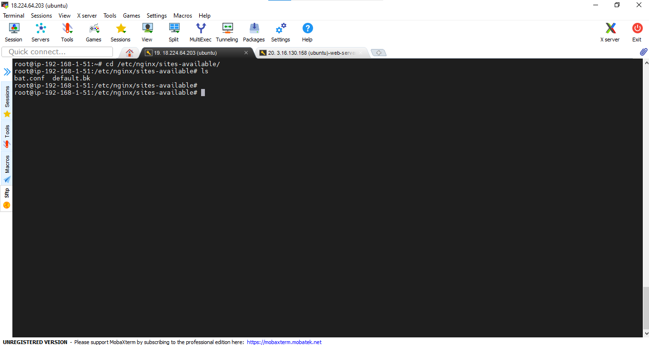

Wrwt

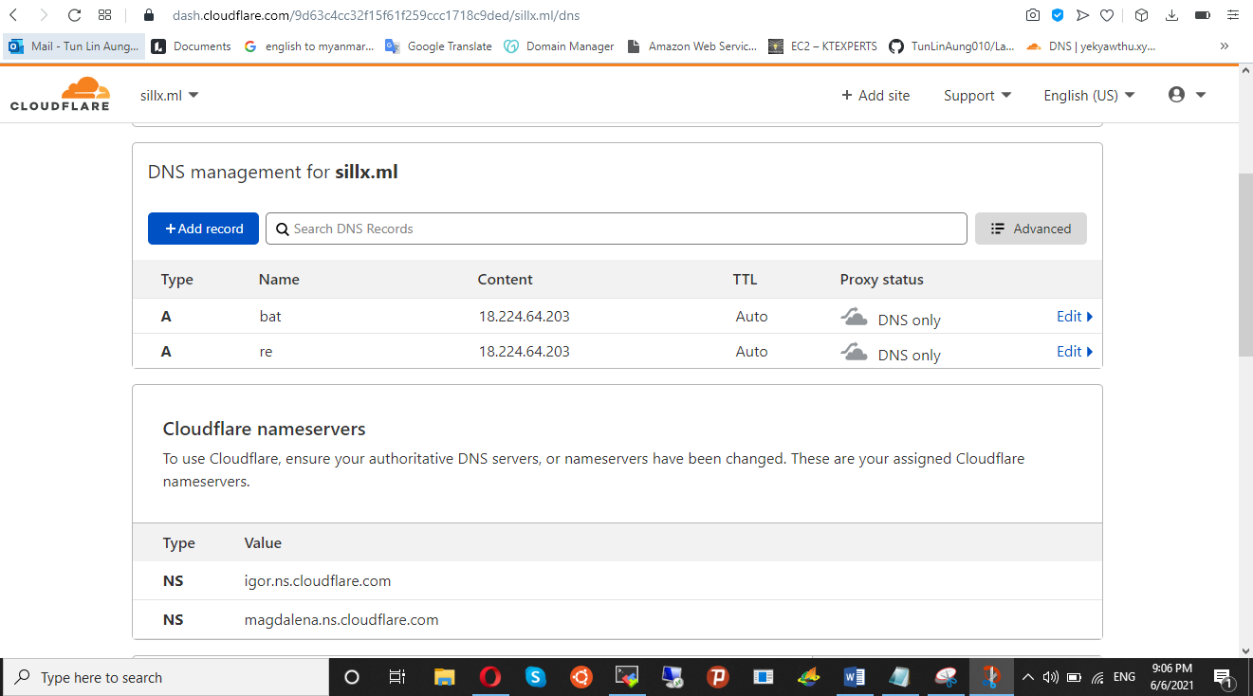

Wrt

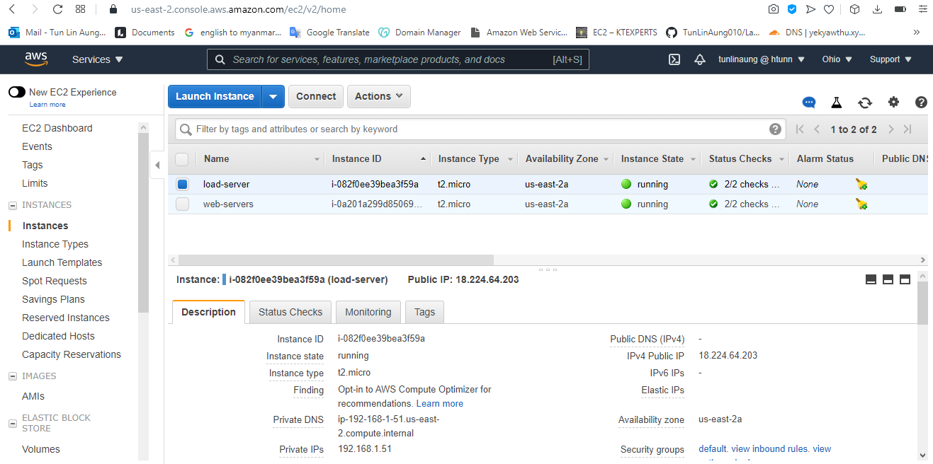

cd /etc/nginx/sites-available/

vim bat.conf

root@ip-192-168-1-51:/etc/nginx/sites-available# cat bat.conf

upstream bat_api {

server 3.16.130.158:8081;

}

upstream bat_dashboard {

server 3.16.130.158:8082;

}

server {

listen 80;

server_name bat.sillx.ml;

rewrite ^ https://$server_name$request_uri? permanent;

access_log /var/log/nginx/log/bat/access.log;

error_log /var/log/nginx/log/bat/error.log;

index index.html index.htm;

}

server {

listen 443 ssl;

server_name bat.sillx.ml;

# ssl on;

ssl_certificate /etc/letsencrypt/live/bat.sillx.ml/fullchain.pem; # managed by Certbot

ssl_certificate_key /etc/letsencrypt/live/bat.sillx.ml/privkey.pem; # managed by Certbot

include /etc/letsencrypt/options-ssl-nginx.conf; # managed by Certbot

ssl_dhparam /etc/letsencrypt/ssl-dhparams.pem; # managed by Certbot

access_log /var/log/nginx/log/bat/access.log;

error_log /var/log/nginx/log/bat/error.log;

index index.html index.htm;

location / {

proxy_pass http://bat_dashboard;

proxy_next_upstream error timeout invalid_header http_500 http_502 http_503 http_504;

proxy_redirect off;

proxy_buffering off;

proxy_set_header Host $host;

proxy_set_header X-Real-IP $remote_addr;

proxy_set_header X-Forwarded-For $proxy_add_x_forwarded_for;

}

location /api/ {

proxy_pass http://bat_api/;

proxy_next_upstream error timeout invalid_header http_500 http_502 http_503 http_504;

proxy_redirect off;

proxy_buffering off;

proxy_set_header Host $host;

proxy_set_header X-Real-IP $remote_addr;

proxy_set_header X-Forwarded-For $proxy_add_x_forwarded_for;

}

}

root@ip-192-168-1-51:/etc/nginx/sites-available#

For dashboard

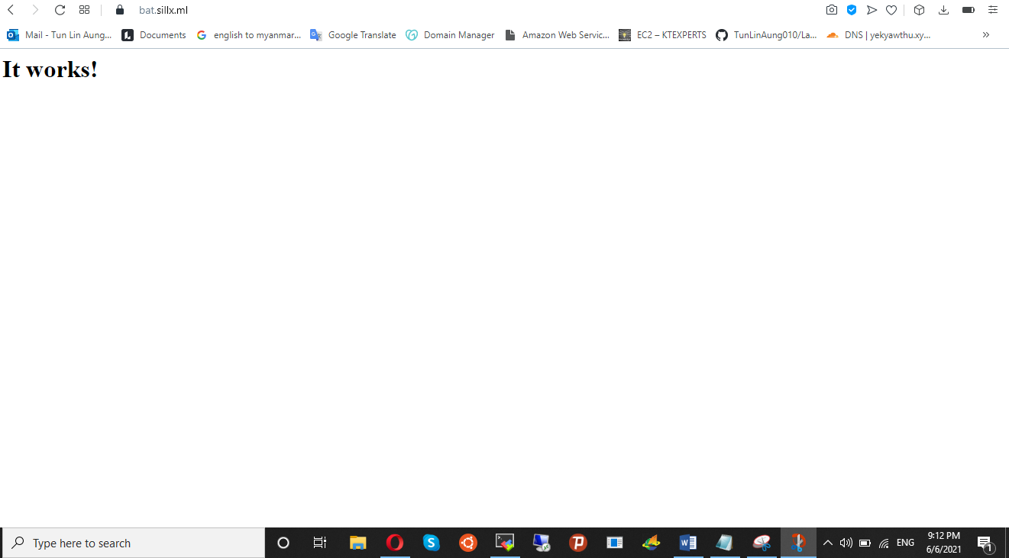

For api

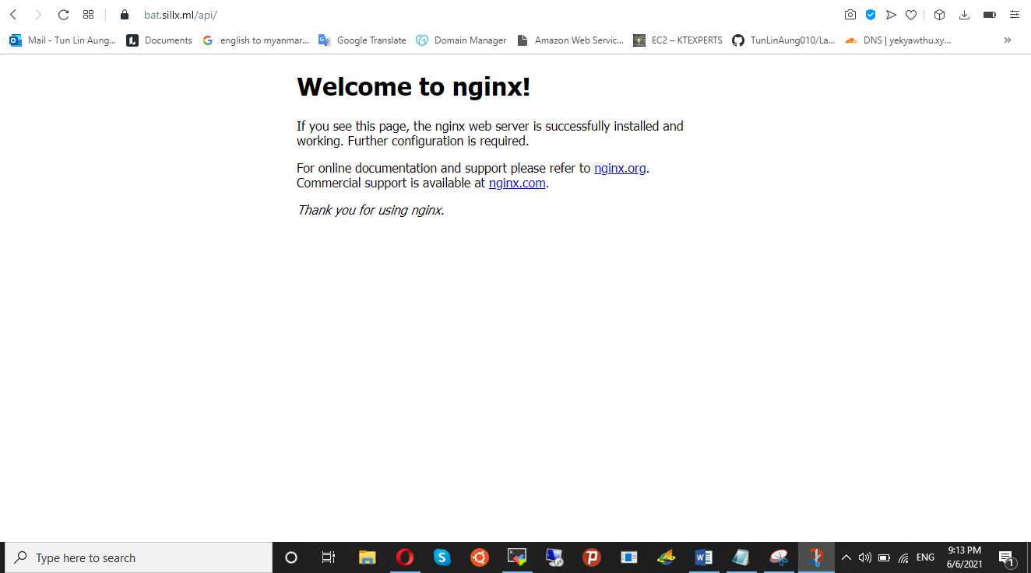

Foweor